S3 bucket

Lab 1: To create s3 bucket without permisions
Step1:create bucket
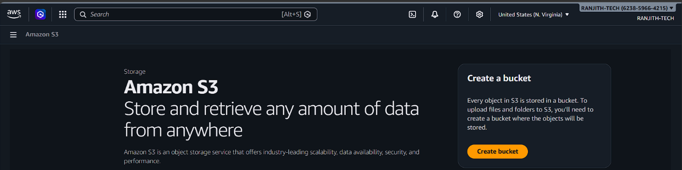
All options are defaults
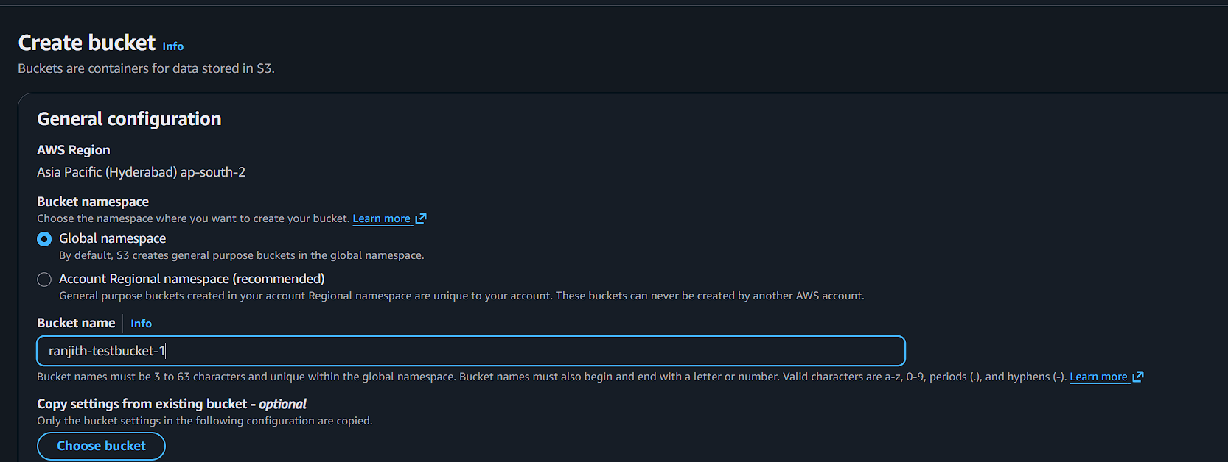
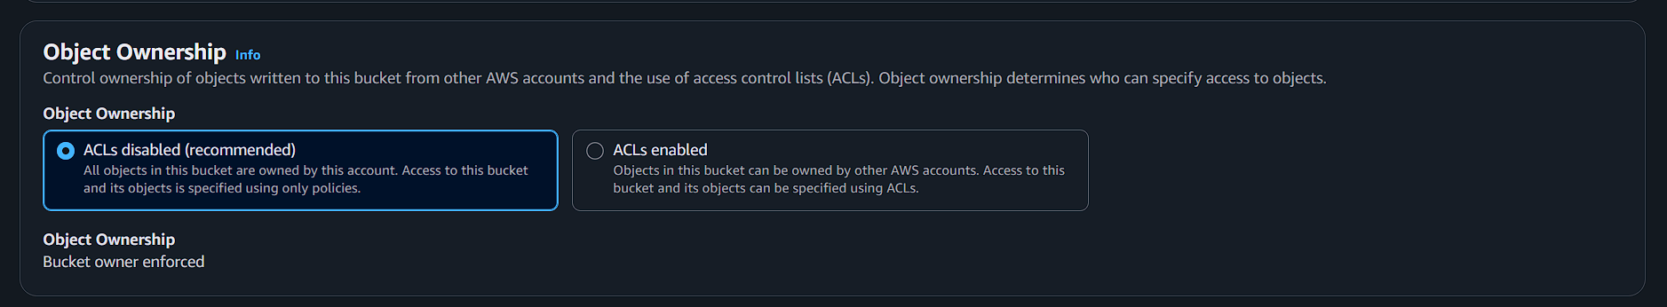

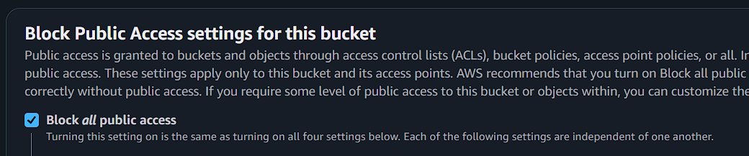

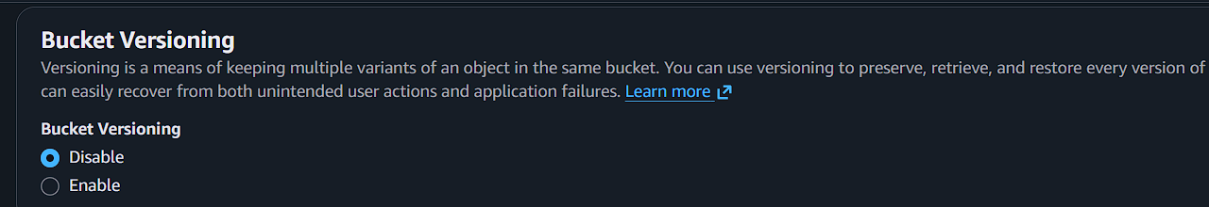
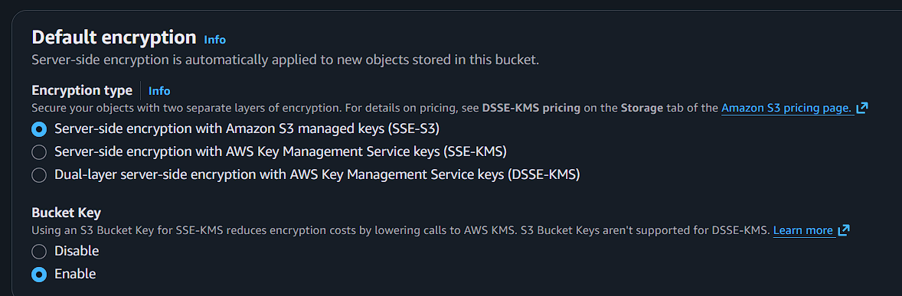
Step 2:upload any files or documents
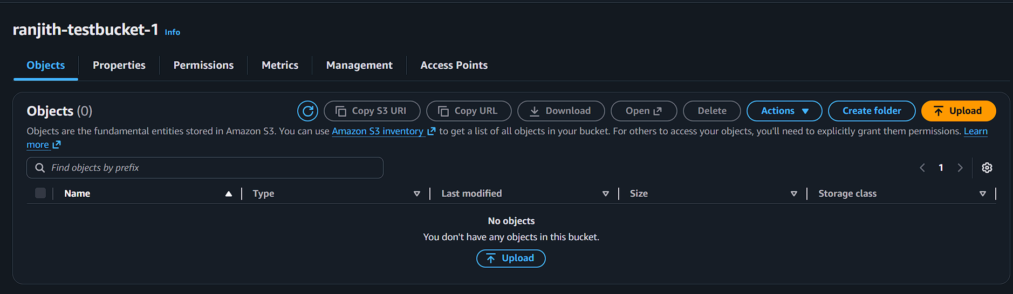
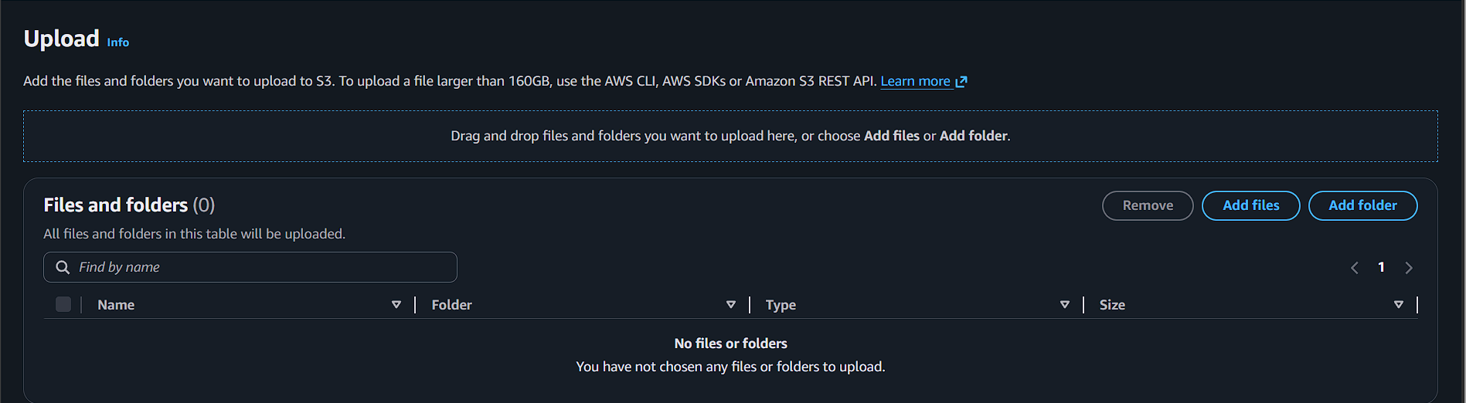
Click add files
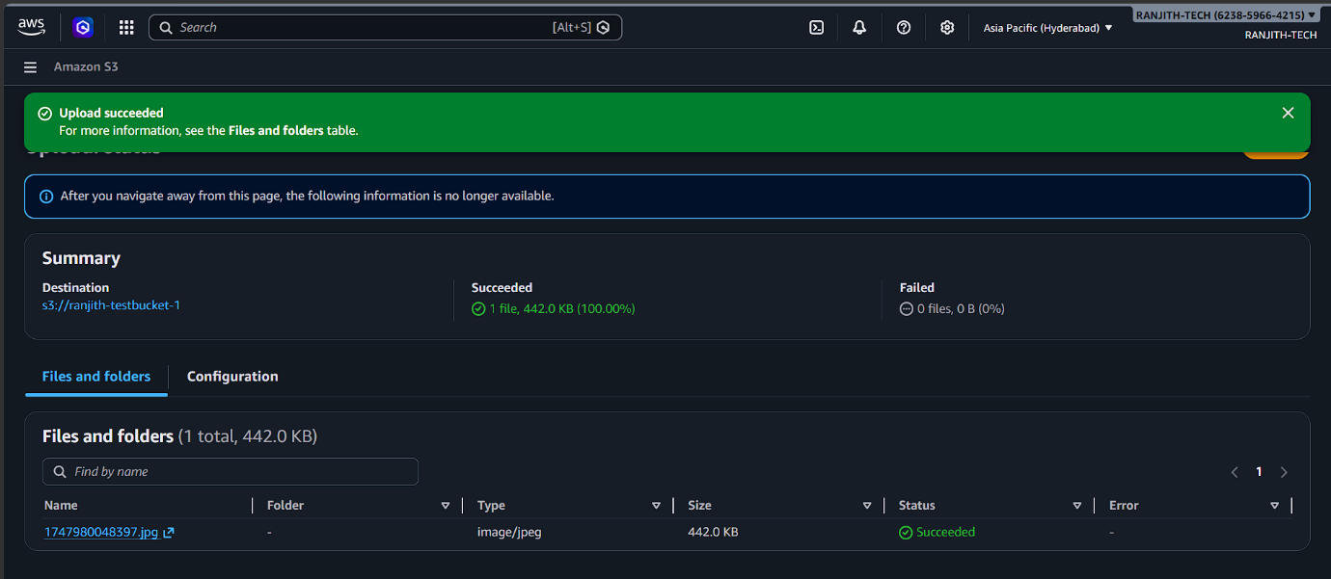

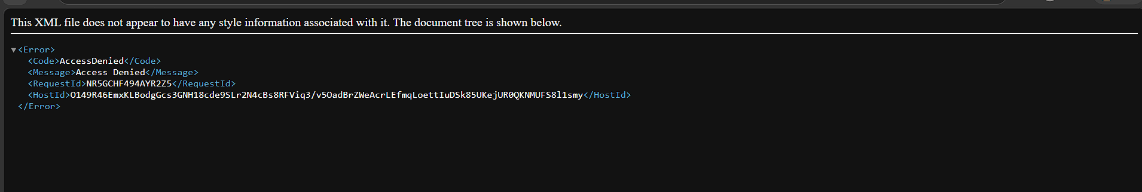

Lab 2: Attach with permissions
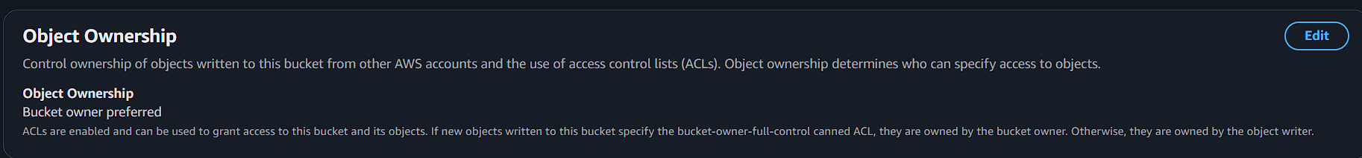
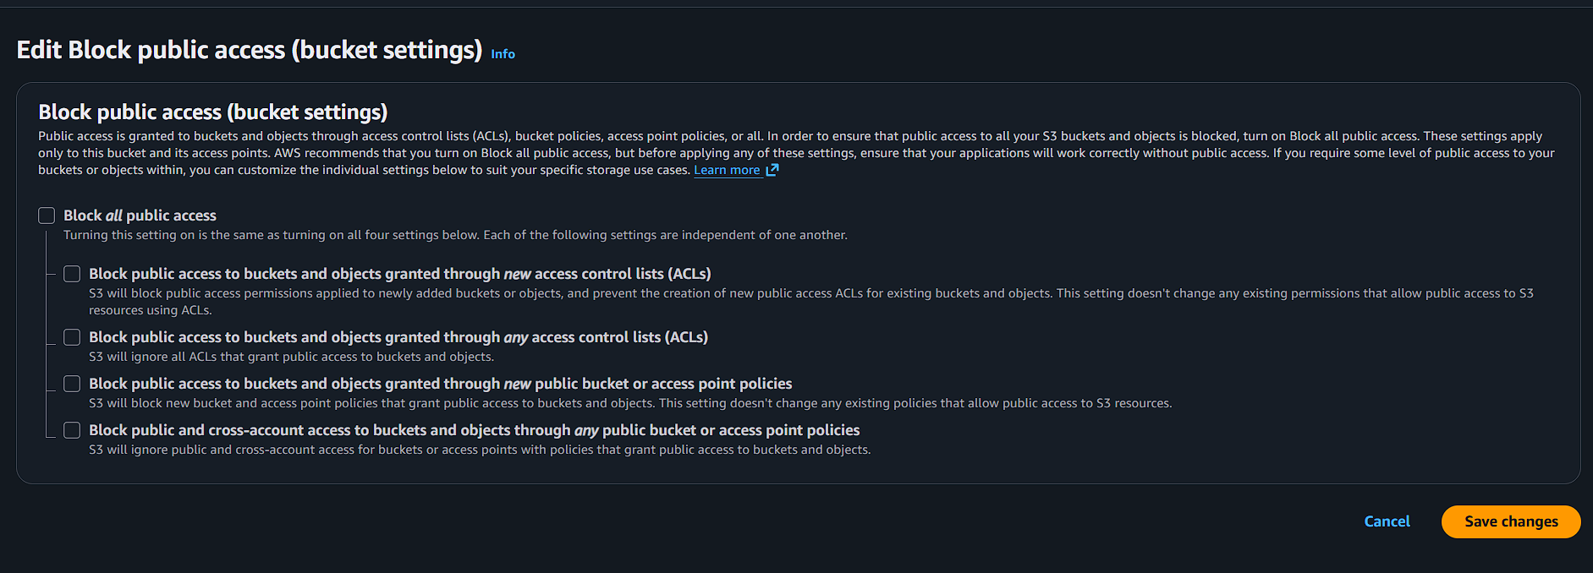
Next click the image then go to image permission
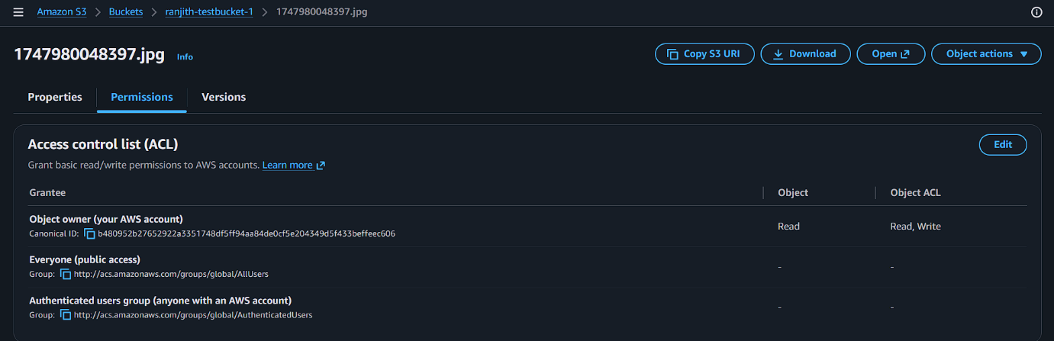
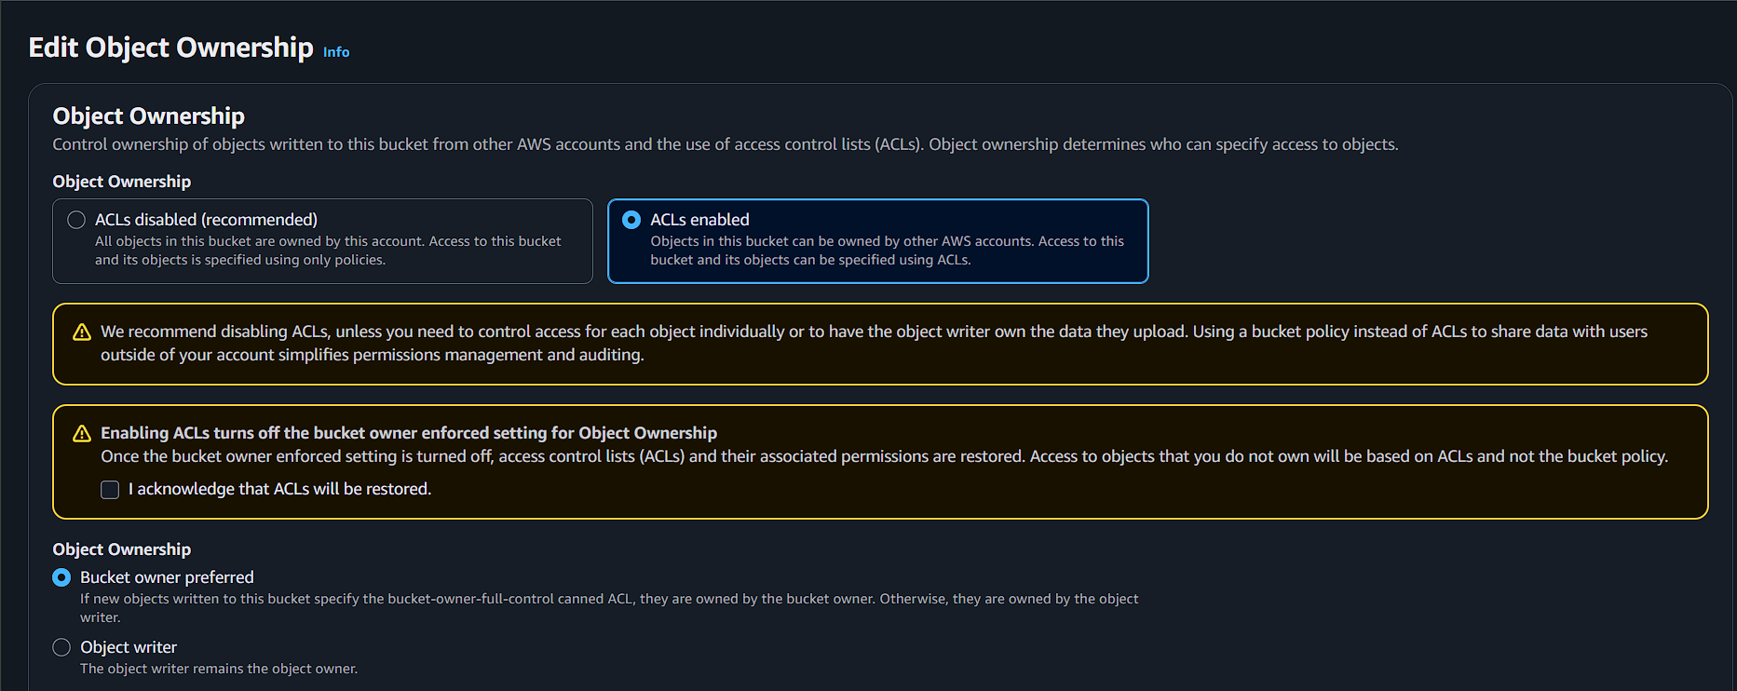

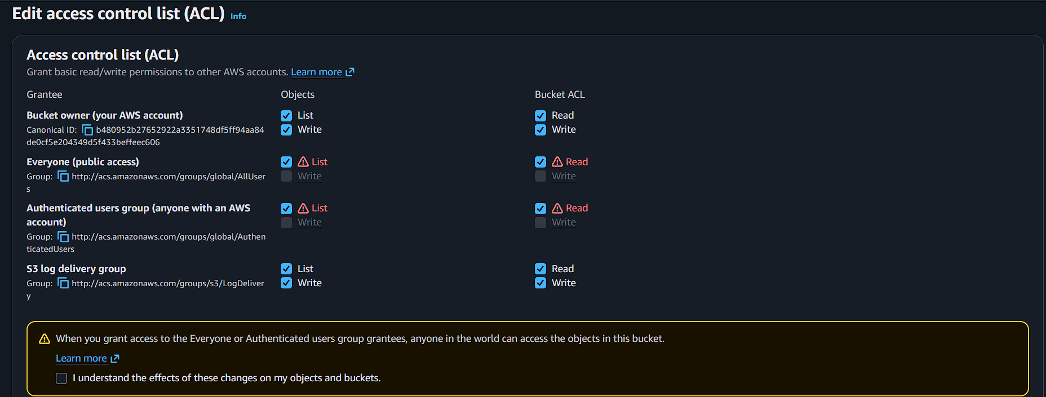

Click edit
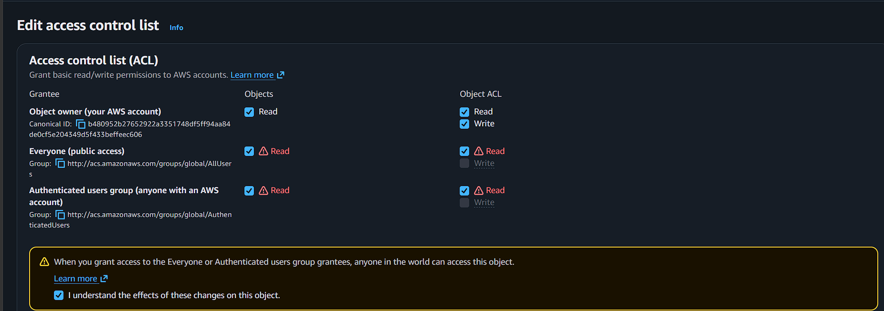

Refresh the page
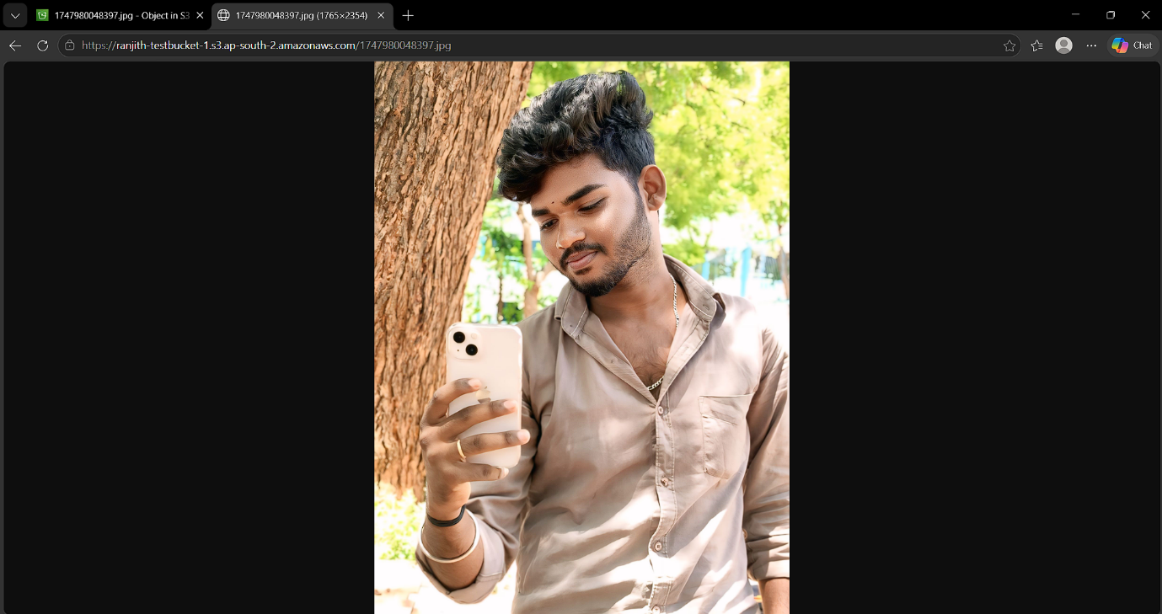

Lab 3: Enable versioning
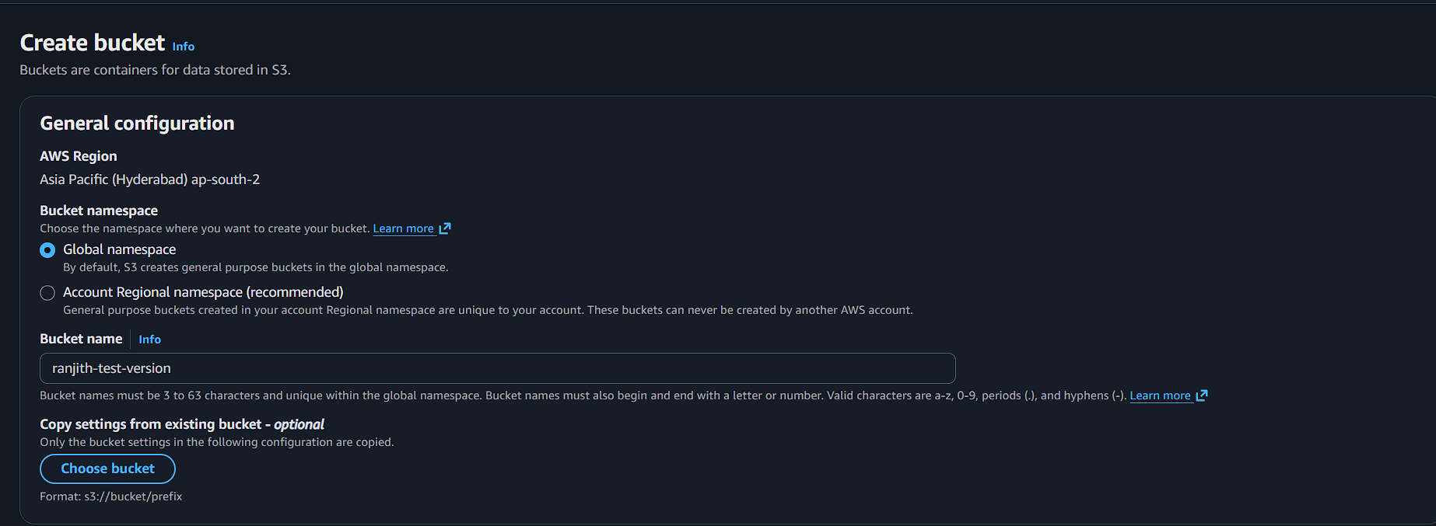
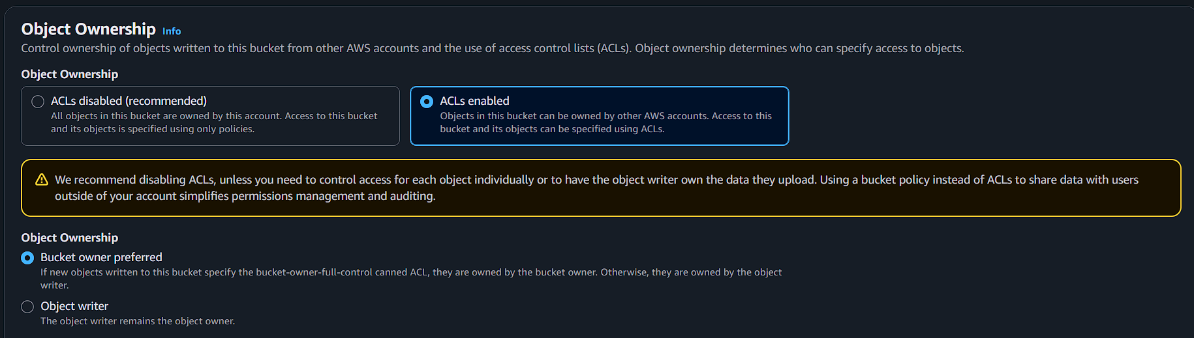
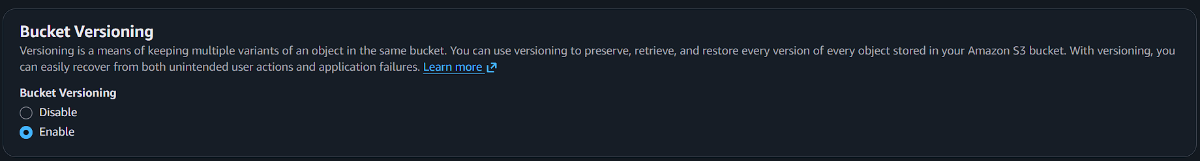
Create any text-file
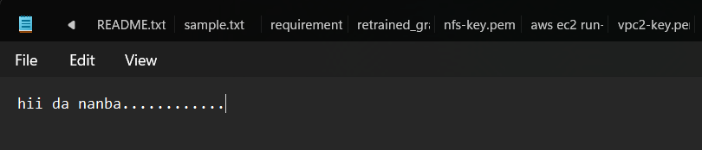

Upload the text-file in the bucket
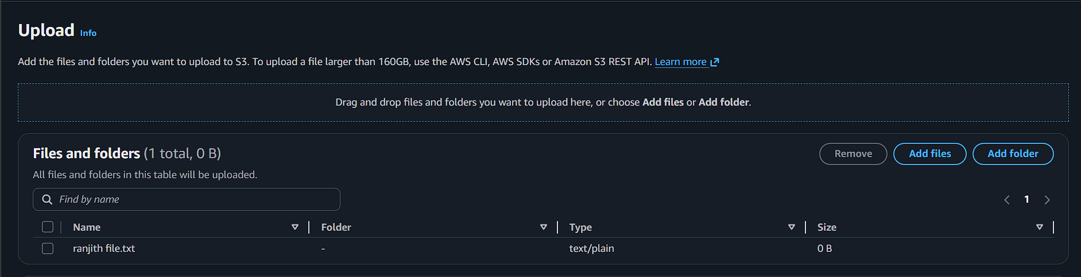
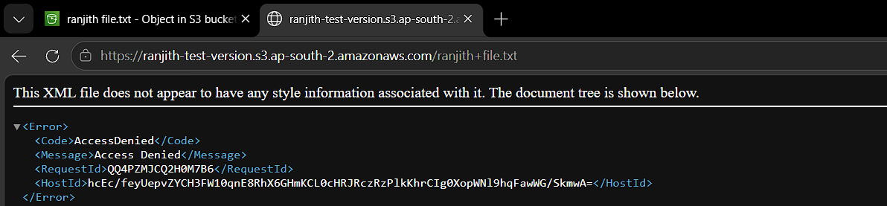
Why
Because not give the permissions for text file
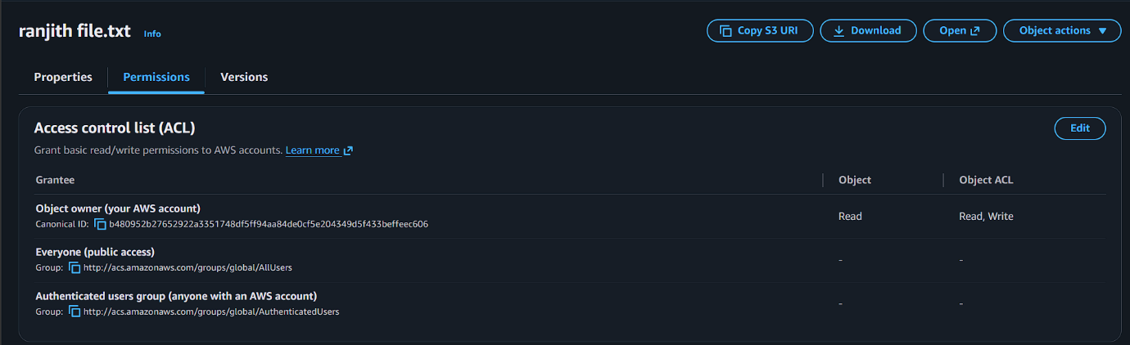
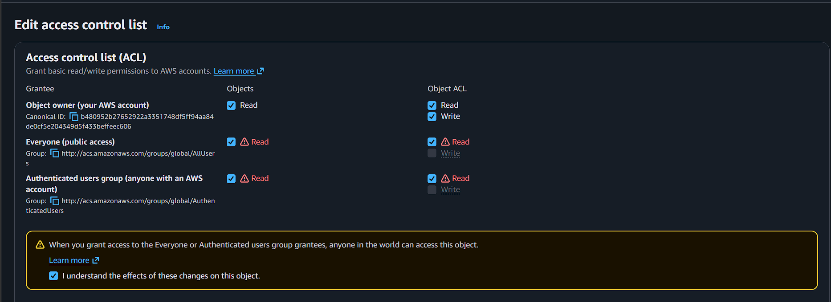
Now check

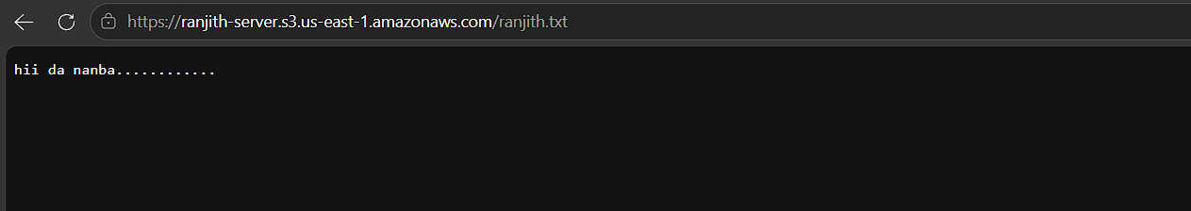

Edit the contents in the text-file
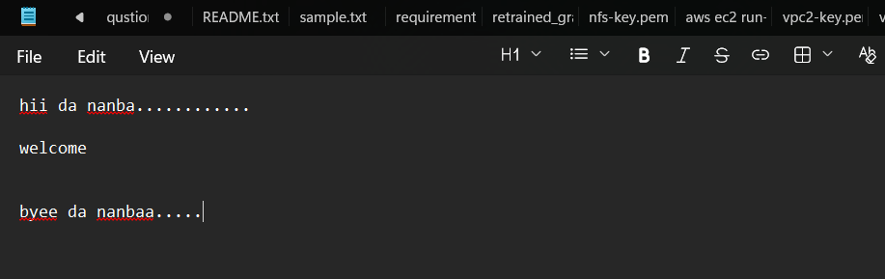
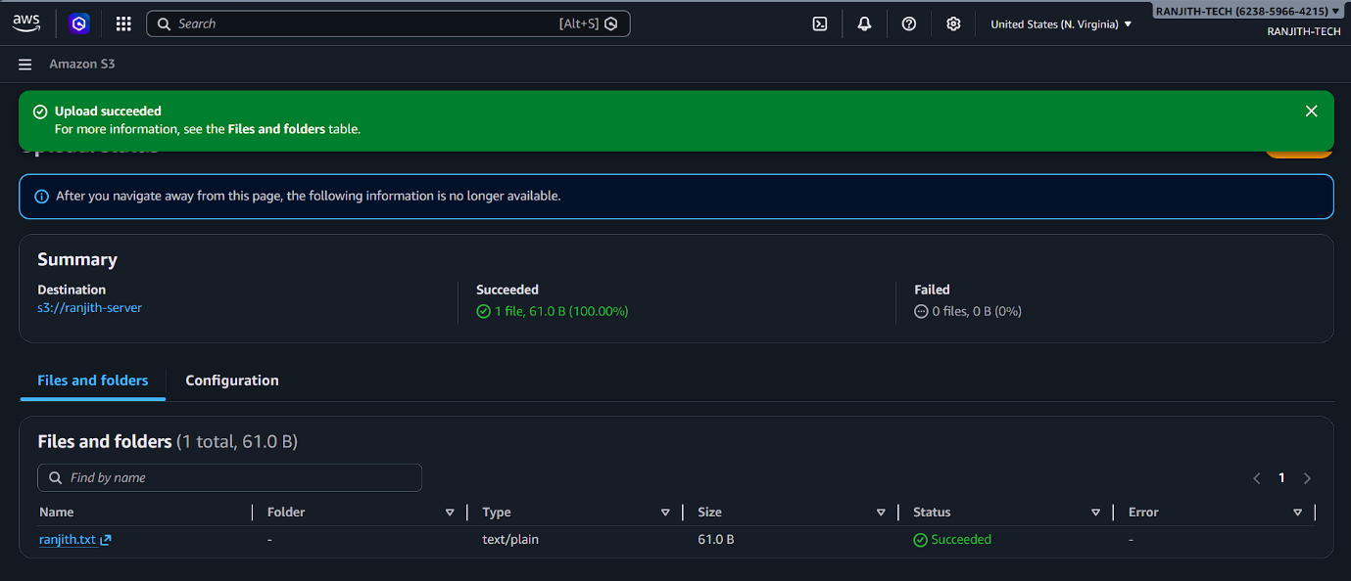

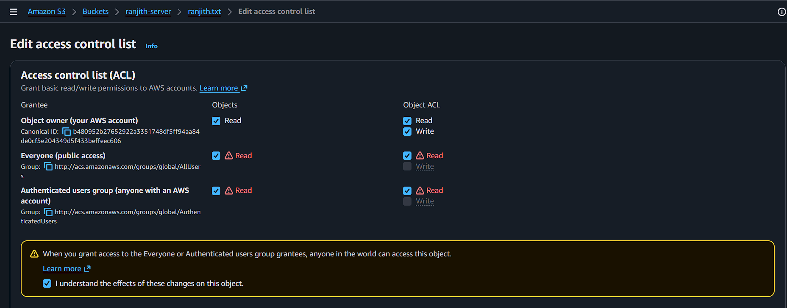

Check the update version
